Experiment 13:
Aim:
Write a Pandas program to detect missing values of a given DataFrame. Display True or False.
Python code:
import pandas as pd
import numpy as np

# Create DataFrame
data = {
"Name": ["Alice", "Bob", "Charlie", "David", "Eva"],
"Age": [25, np.nan, 30, 28, np.nan],
"Marks": [85, 90, np.nan, 75, 88],
"City": ["Delhi", "Mumbai", np.nan, "Chennai", "Hyderabad"]
}

df = pd.DataFrame(data)

print("Original DataFrame:")
print(df)

# Detect missing values
print("\nMissing Values (True/False):")
print(df.isnull())
Output:
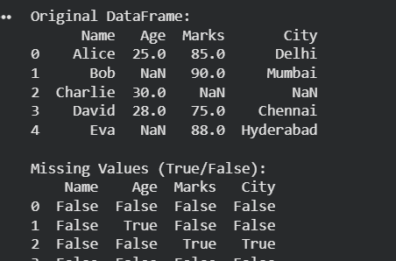
Experiment 14:
14.Create a dataframe of ten rows, four columns with random values. Write a Pandas program to set dataframe background Color black and font color yellow.
Python code:
import pandas as pd
import numpy as np

# Create DataFrame
data = {
"Name": ["Alice", "Bob", "Charlie", "David", "Eva"],
"Age": [25, np.nan, 30, 28, np.nan],
"Marks": [85, 90, np.nan, 75, 88],
"City": ["Delhi", "Mumbai", np.nan, "Chennai", "Hyderabad"]
}

df = pd.DataFrame(data)

print("Original DataFrame:")
print(df)

# Replace missing values
df["Age"] = df["Age"].fillna(df["Age"].mean()) # Replace with mean
df["Marks"] = df["Marks"].fillna(0) # Replace with 0
df["City"] = df["City"].fillna("Unknown") # Replace with text

print("\nDataFrame after replacing missing values:")
print(df)
output:
